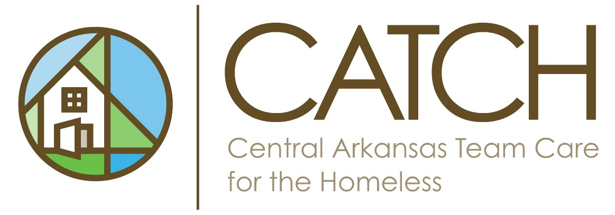
Checklist for FY 2025 CATCH CoC Project Application Submission
Due Friday, December 12, 2025 by 4:00pm, please email application to Cecilia Cole ccole@littlerock.gov (all items must be sent). Late applications will NOT be accepted after the deadline date.
- _____PDF copy of e-snaps application. (Use the application instructions from HUD. Please do not press submit button—keep it in edit mode. You will submit after rank and review process is complete in case any changes need to be made.)
  - _____ Double check Grant number (renewal project only)—your number should match the GIW but will auto populate with the appropriate fiscal year grant number. The last 4 digits will need to be updated.
  - _____ Project start and end date. (renewal project only) The Start date must include the 1st of the month as a date. The end date must be in Calendar Year 2025. For example: start: 10/01/2024 end: 09/30/2025 (renewals MUST use the same project start date and project end date as on their previous application.)
- _____Supplemental Application to Regular NOFO (New or Renewal)* (READ EACH QUESTION CAREFULLY AND ANSWER THOROUGHLY)
- _____Attachments:
Renewal Project**:
- Cover letter from most recent agency audit
- Most recent HUD monitoring Report
- Letter from Continuum of Care showing Active Participation
- Emergency Transfer Plan for Housing
- Anti-Discrimination Policies and Procedures
- MOUs with public health agencies (if applicable)
- MOUs with public housing authorities (if applicable)
- Copy of most recently submitted APR report in SAGE
- Copy of most recently submitted Annual Performance Report for DV Providers (ensuring submission without any confidential information released)
- Cover letter from most recent agency audit
- MOU or written agreement for all listed as partners in project application
- Match/leverage letters—dated no earlier than May 1st of the application year
- 2991—Certification of consistency with Consolidated Plan—for all applicable jurisdictions dated (dated no earlier than May 1st of the application year)
- All forms to be submitted in esnaps with the application (will be found in esnaps)
  - SF424 (1A-1F)
  - HUD 2880 (1G)
  - HUD 50070 (1H)
  - HUD 2996
  - HUD 426 Form
  - Certification regarding lobbying
  - SF-LLL (1J)
  - SF-424B (1K)
  - SF-424D (1L)
- DV Projects comparable database checklist (if applicable)
New Projects:
- Cover letter from most recent agency audit
- Most recent HUD monitoring Report
- Letter from Continuum of Care showing Active Participation
- Emergency Transfer Plan for Housing
- Anti-Discrimination Policies and Procedures
- MOUs with public health agencies (if applicable)
- MOUs with public housing authorities (if applicable)
- Copy of most recently submitted APR report in SAGE
- Copy of most recently submitted Annual Performance Report for DV Providers (ensuring submission without any confidential information released)
- Cover letter from most recent agency audit
- MOU or written agreement for all listed as partners in project application
- Match/leverage letters—dated no earlier than May 1st of the application year
- 2991—Certification of consistency with Consolidated Plan—for all applicable jurisdictions dated (dated no earlier than May 1st of the application year)
- All forms to be submitted in esnaps with the application (will be found in esnaps)
  - SF424 (1A-1F)
  - HUD 2880 (1G)
  - HUD 50070 (1H)
  - HUD 2996
  - HUD 426 Form
  - Certification regarding lobbying
  - SF-LLL (1J)
  - SF-424B (1K)
  - SF-424D (1L)
- DV Projects comparable database checklist (if applicable)

*Renewal for HMIS: do not complete the supplemental application.
- Renewal for Coordinated Entry: Complete questions 24-28.
- Planning Grant: do not complete the supplemental application.
**Renewal for HMIS: you will submit all items under #3 except for items pertaining to DV, good standing letter, and MOU for partners.
- Renewal for Coordinated Entry: you will submit all items under #3 except for items pertaining to DV and MOU partnerships.
- Planning Grant: do not submit items under #3.

